Prepared for Insert vendor name here

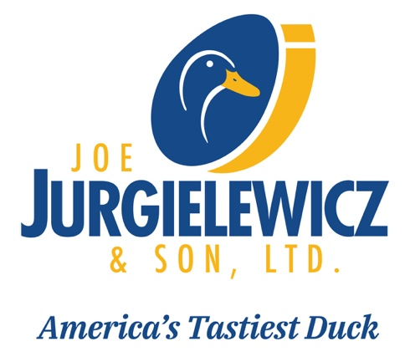 |  | 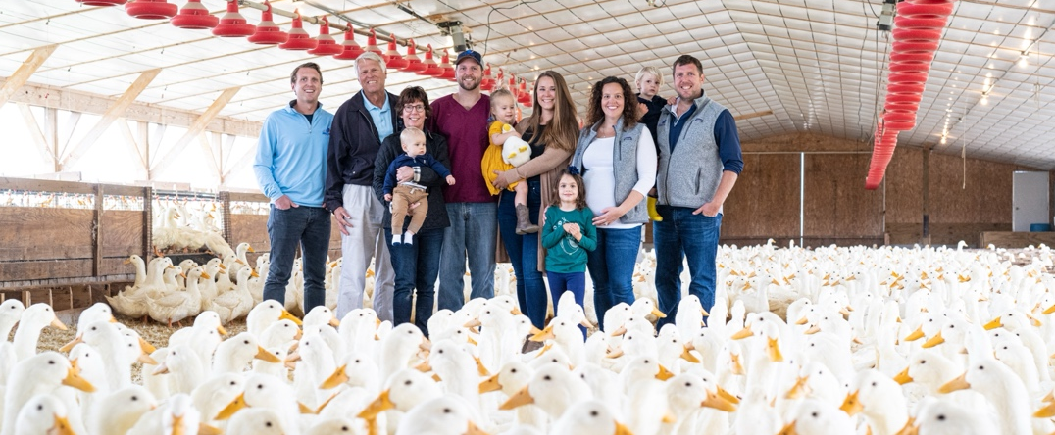
A happy and healthy duck is a tasty duck. And each Joe Jurgielewicz & Son, Ltd. (JJS) duck is minimally processed, USDA-inspected and graded to ensure the healthiest and highest quality duck. For nearly
a century, we’ve been a leading provider of premium fresh and frozen duck to the food service industry, retailers and home consumers.
Our 92-Year Tradition  Joe Jurgielewicz & Son, Ltd. (JJS) is one of the leading Pekin duck suppliers in North America. We employ over 250 Pennsylvanians and partner with 43 Pennsylvania farm families to raise JJS Pekin ducks.  These ducks are descendants of the original Long Island ducks that  Dr. Joe’s grandparents raised on their farm in Long Island.  Over the years, JJS staff geneticists have hand-selected the perfect  duck breed for our clients. Our breed is favored by leading chefs for  its perfectly balanced meat-to-fat ratio, ensuring the signature, succulent flavor of the famous JJS Tasty Duck.  Joe Jurgielewicz & Son, Ltd. was founded on the core belief that  all of our ducks must be treated humanely. Our ducks are raised  free-roaming in large temperature-controlled barns and are fed  only a nutritious diet of corn and soybeans, and never any  antibiotics or growth hormones.  We’re also the only duck farm in America with two “round-the-clock” veterinarians and a full-time duck welfare specialist to train  employees and conduct duck welfare audits.  Our humane and sustainable methods help ensure that our ducks  are the industry’s biggest, with a higher fat to meat ratio sought by chefs and consumers alike. As demand for duck continues to grow, we’re ready to provide the highest quality Pekin duck products  possible. From our eco-friendly farm in Hamburg, PA, JJS fresh  duck is less than a day away from restaurants in New York and  Washington D.C. |  |  | Today, the Jurgielewicz family is proud to continue our 92-year tradition of providing the highest-quality Pekin duck products and world-class service  to clients worldwide, and we look forward to building on that tradition for generations to come.
 |  |  | Experience our tasty duck
Duck Breast
Duck Legs
Grade A Whole Duck
Head-on, Feet-on Whole Duck
Duck Carnitas
Duck Leg Confit
Rendered Duck Fat
Ground Duck
 |  |  | 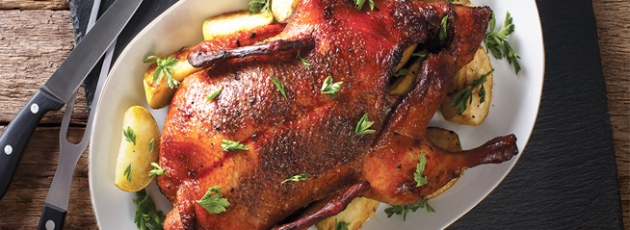
 | Joe Jurgielewicz & Son, Ltd.  189 Cheese Lane | Hamburg, PA 19526  tastyduck.com |  | Contact name  Contact phone number  Contact email address

